MAIN PAGE
NATURAL WOOD SIDING & SOFFIT
(Timeless Warmth, Lasting Impact)
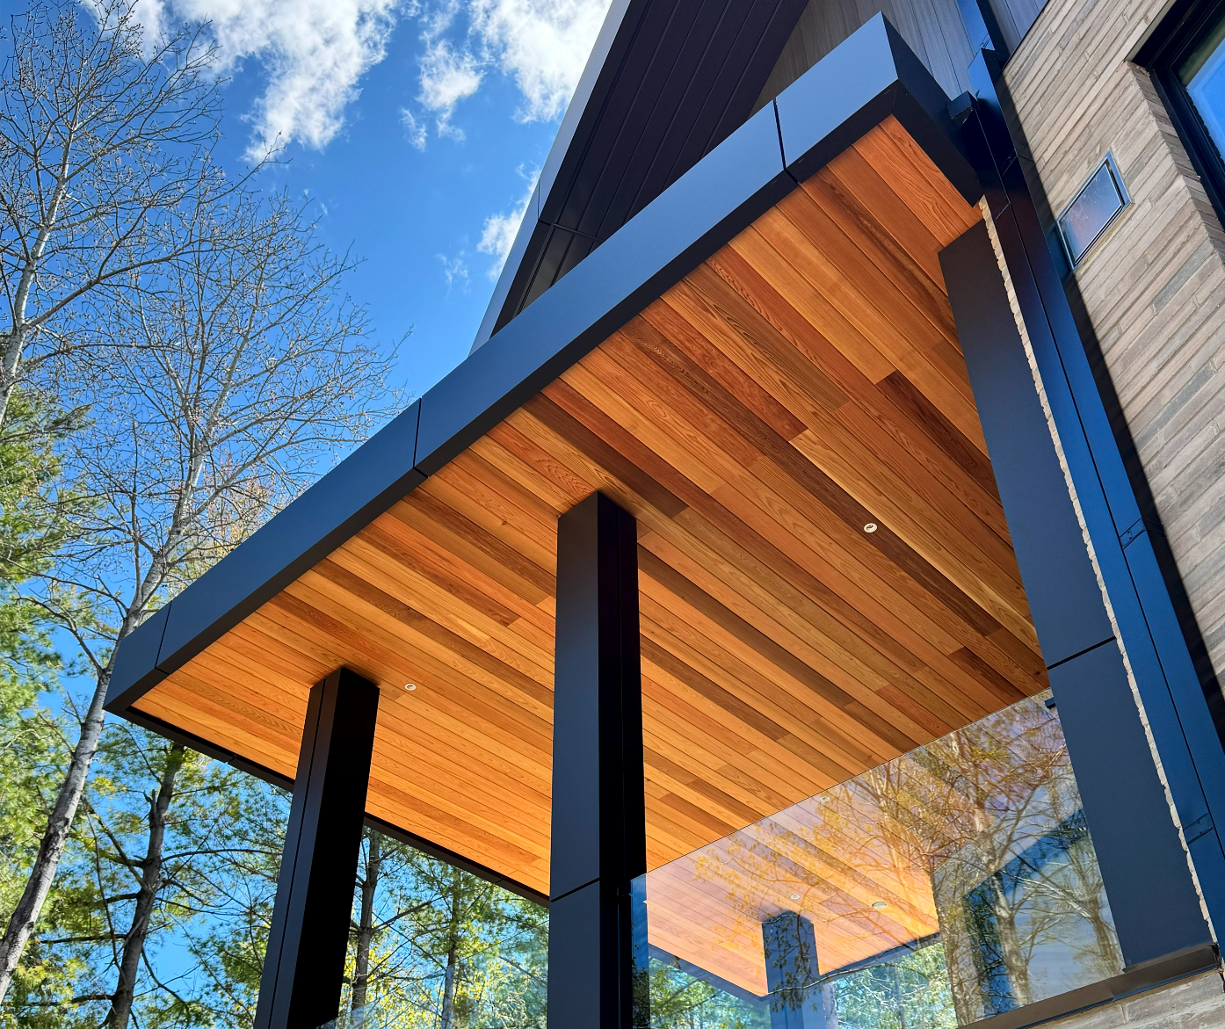
Industrial / Residential / Commercial / Agricultural
At CladCan, we bring you the unmatched character of real wood through a premium collection of siding and soffit products designed to elevate any exterior. Our line includes carefully selected natural cedar, various genuine wood species, engineered wood siding options, and distinctive styles such as board and batten and tongue-and-groove.
From the rustic charm of Eastern white cedar to the dramatic elegance of charred wood finishes, each product is built for lasting performance and visual appeal. Kiln-dried and precision-milled for stability, our wood sidings are available raw, factory-stained, or custom-finished to match your design vision.
Prefer low-maintenance solutions? Our engineered options deliver the rich look of wood with enhanced durability and weather resistance—ideal for modern builds and high-performance exteriors.
Whether you’re after natural beauty, bold texture, or a maintenance-friendly alternative, our wood siding and soffit collection offers timeless design with lasting value.
Speak with an Expert Get personalized advice and expert guidance to achieve your project goals with confidence.

CHARRED WOOD SIDING & SOFFIT- ICON
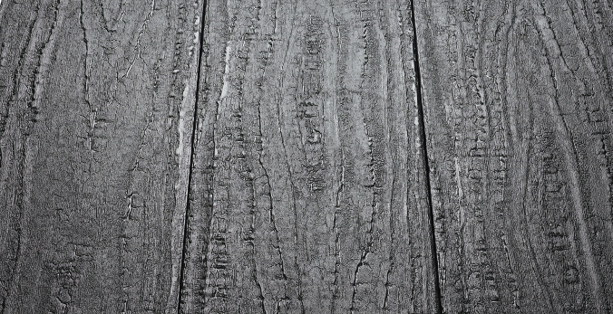
Burned to Endure. Built to Inspire.”
Perfect for modern builds, luxury retreats, or timeless renovations, charred wood transforms exteriors into powerful statements. Sustainably made. Artistically crafted........ (Learn More / Expand)

CHARRED WOOD SIDING & SOFFIT (EXPANDED)
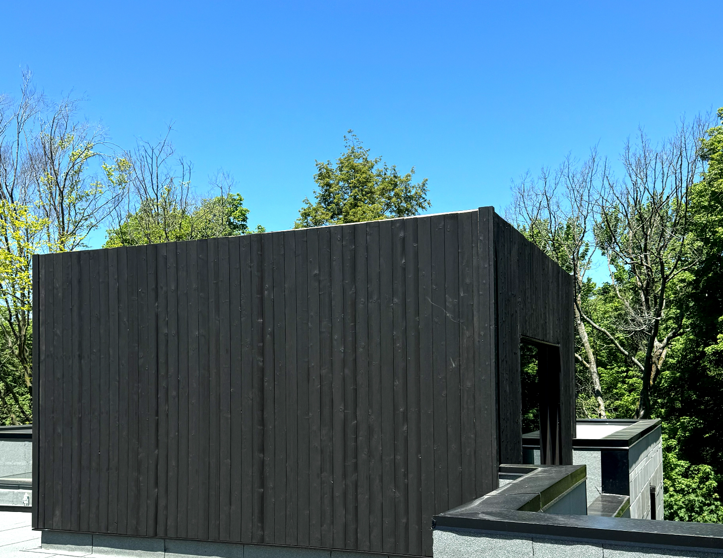
Expanded … Burned to Endure. Built to Inspire.”
Perfect for modern builds, luxury retreats, or timeless renovations, charred wood transforms exteriors into powerful statements. Sustainably made.
Artistically crafted Discover the striking fusion of ancient tradition and modern design with charred wood siding and soffits, a bold yet timeless option that sets your project apart in both beauty and performance.
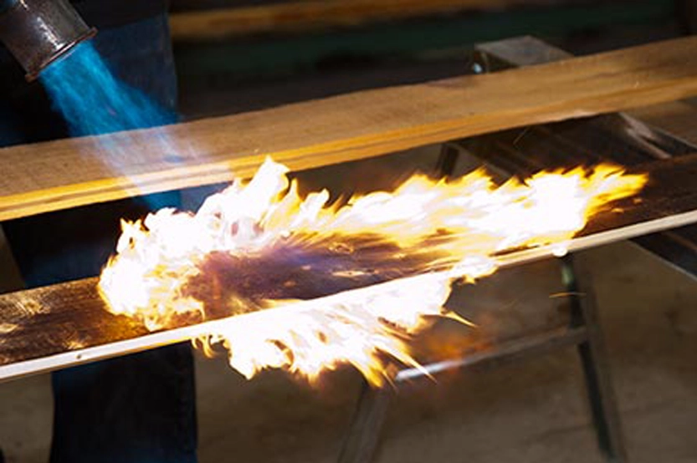
Rooted in the centuries-old Japanese technique of Yakisugi, often referred to as Shou Sugi Ban, this process involves delicately charring the surface of natural wood to enhance its strength, longevity, and aesthetic richness. The result is a deep, smoky-black finish with dramatic grain contrast and an unmistakable texture that captures light and shadow in ways no paint or stain ever could.
Here’s how the process unfolds:
1. Burn
Each plank is carefully exposed to flame until the surface reaches the desired level of char, creating a distinctive carbon layer and revealing bold grain patterns.
2. Brush & Rinse
The charred surface is gently brushed to remove loose soot and ashes, then washed with clean water to prepare it for the final stage.
3. Oil Finish
The wood is oiled to nourish the fibers, seal in the beauty, and enhance longevity—bringing out a rich, dimensional look that lasts for decades with minimal maintenance.
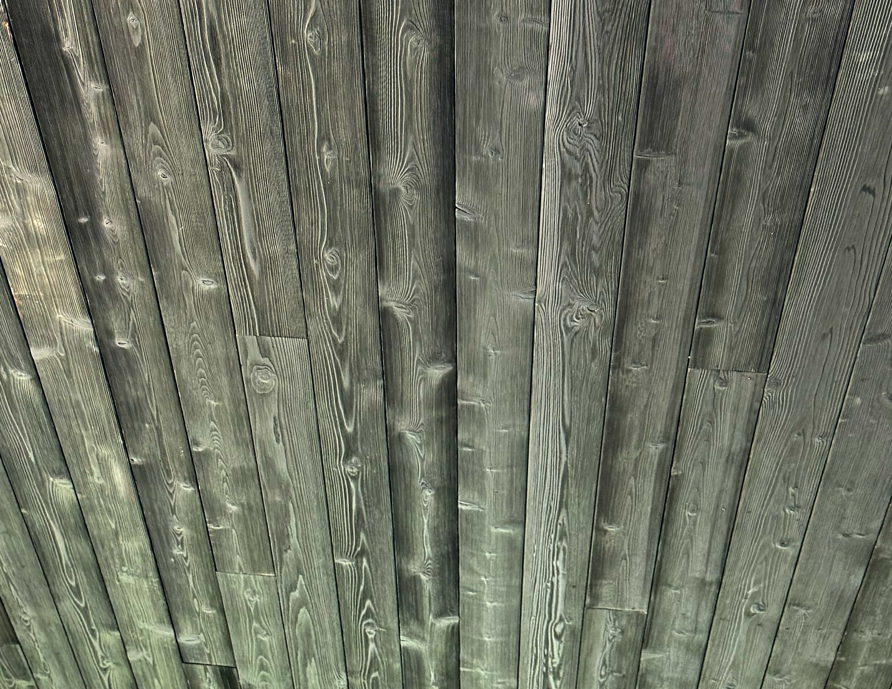
But this technique does more than create visual impact, it naturally fortifies the wood. Through controlled burning, the outer layer becomes carbonized, increasing resistance to moisture, UV, rot, insects, and even fire. With only minimal maintenance, such as oiling once every 10 to 15 years, charred wood can last decades, even generations.

Profile Options:

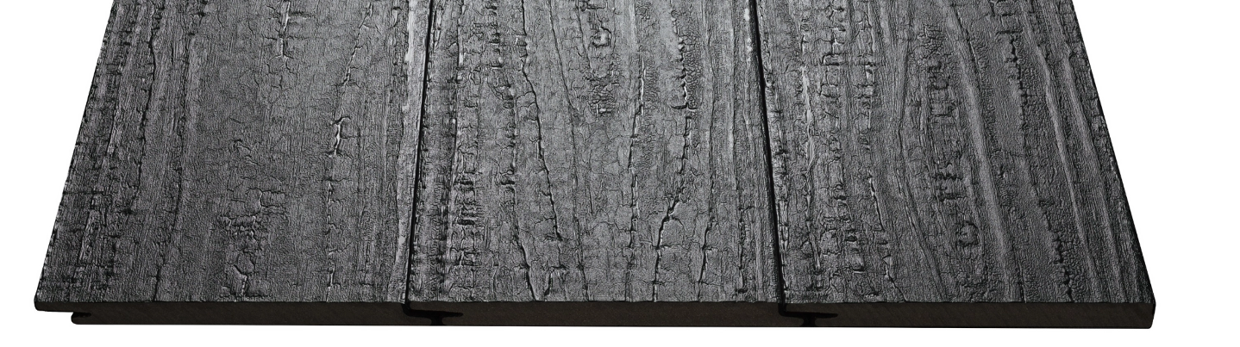

At CladCan, we’ve brought this ancient technique to today’s architectural language—offering custom charred siding and soffit panels made from premium wood species, kiln-dried and precision-milled for flawless installation. Whether used as a bold accent or across an entire façade, our charred wood collection delivers an unmatched combination of natural elegance, deep character, and lasting performance.

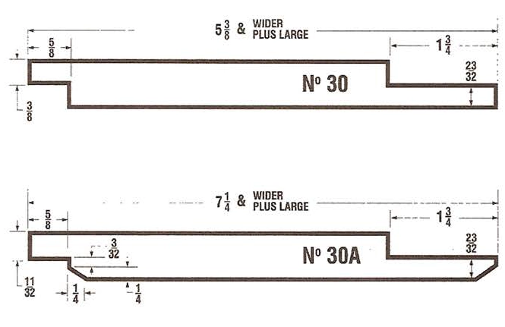
Selected Finishes:
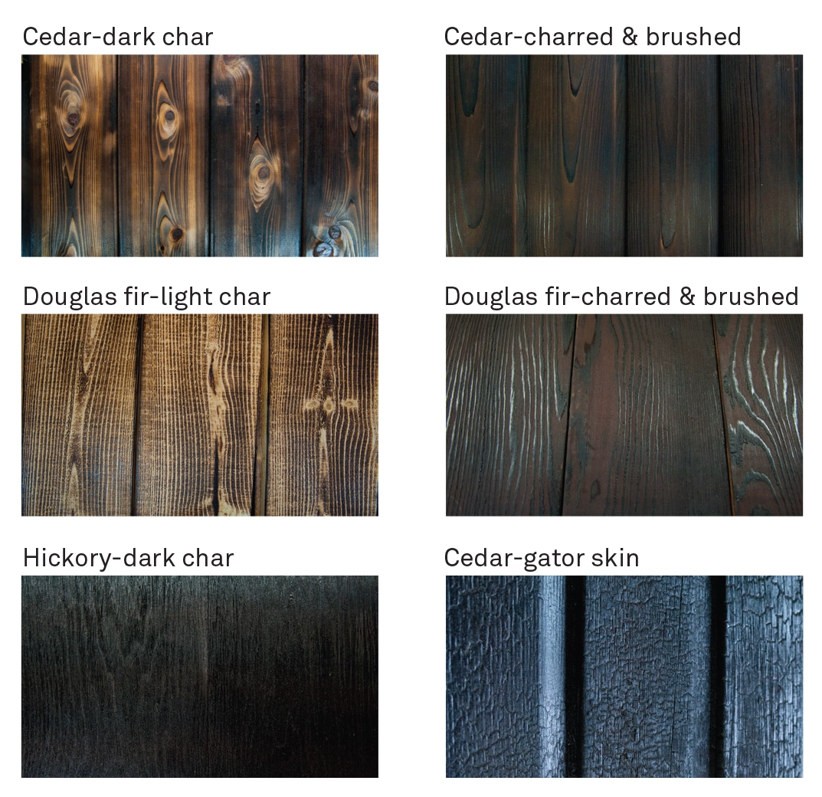

Versatile Applications
- Exterior Siding
Make a bold architectural statement with timeless texture and durability for residential and commercial façades.
- Fencing & Decking
Bring modern elegance and weather-resistant performance to outdoor living spaces with a unique blackened grain aesthetic.
- Interior Walls & Millwork
Create dramatic focal points inside with warm, tactile surfaces that elevate any space—from feature walls to custom ceiling slats and millwork.

Key Benefits:
- Unique aesthetic appeal
- Discover exquisite designs that capture attention with impressive colors and patterns.
- Protection from rotting & decay
- Prevent wooden surfaces from wear & tear and maintain an irresistible look.
- Increased durability & performance
- Ensure water resistance and fire-retardant properties of the wooden surface.
- Exceptional longevity
- The carbon layer that results from charring provides protection over the years.

